**Estructura**

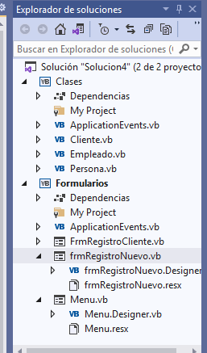

**Clases**

**Clase base PERSONA**

Public Class Persona

Private _apellidos As String

Private _nombres As String

Private _documento As String

Private _tipo As String

'Public Property Apellidos As String

' Get

' End Get

' Set(value As String)

' End Set

'End Property

Public Property Apellidos As String

Get

Return _apellidos

End Get

Set(value As String)

_apellidos = value

End Set

End Property

Public Property Nombres As String

Get

Return _nombres

End Get

Set(value As String)

_nombres = value

End Set

End Property

Public Property Documento As String

Get

Return _documento

End Get

Set(value As String)

_documento = value

End Set

End Property

Public Property Tipo As String

Get

Return _tipo

End Get

Set(value As String)

_tipo = value

End Set

End Property

End Class

**Clase hija CLIENTE**

Public Class Cliente

' hereda de la clase Persona

Inherits Persona

'Atributos

Private _categoria As String

Private _codigo As String

'Propiedades

Public Property Categoria As String

Get

Return _categoria

End Get

Set(value As String)

_categoria = value

End Set

End Property

Public Property Codigo As String

Get

Return _codigo

End Get

Set(value As String)

_codigo = value

End Set

End Property

'Metodos

Public Sub GenerarCodigo()

Me._codigo = "C" & Me.Nombres.Substring(0, 3) & "16"

End Sub

End Class

**Clase hija EMPLEADO**

Public Class Empleado

Inherits Persona

'Atributos

Private _tipoContrato As String

Private _sueldo As Double

'Propiedades

Public Property TipoContrato As String

Get

Return _tipoContrato

End Get

Set(value As String)

_tipoContrato = value

End Set

End Property

Public Property Sueldo As Double

Get

Return _sueldo

End Get

Set(value As Double)

_sueldo = value

End Set

End Property

'Metodos

Public Sub calcularSueldo(sueldobase As Double)

If (Me.TipoContrato = "C") Then

Me._sueldo = sueldobase + 350

ElseIf (Me.TipoContrato = "N") Then

Me._sueldo = sueldobase + 750

Else

Me._sueldo = 0

End If

End Sub

End Class

**Formularios**

**Registro Cliente**

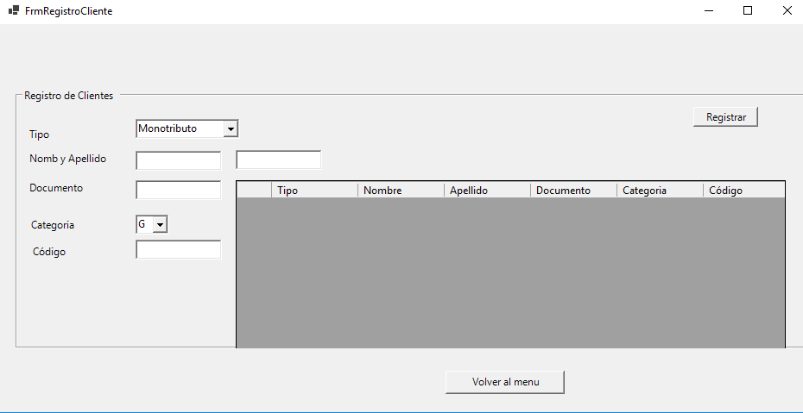

Imports Clases

Public Class FrmRegistroCliente

Private Sub BtnRegistrar_Click(sender As Object, e As EventArgs) Handles BtnRegistrar.Click

Dim Cliente1 As Cliente = New Cliente

Cliente1.Tipo = CboTipo.Text

Cliente1.Nombres = TxtNombre.Text

Cliente1.Apellidos = TxtApellido.Text

Cliente1.Documento = TxtDocumento.Text

Cliente1.Categoria = CboCategoria.Text

Cliente1.GenerarCodigo()

'esto lo agregue para que se vea en el textbox tambien ( no seria necesario)

TxtCodigo.Text = Cliente1.Codigo

GrdDatos.Rows.Insert(0,

Cliente1.Tipo,

Cliente1.Nombres,

Cliente1.Apellidos,

Cliente1.Documento,

Cliente1.Categoria,

Cliente1.Codigo)

End Sub

Private Sub BtnVolver_Click(sender As Object, e As EventArgs) Handles BtnVolver.Click

Menu.Show()

Me.Hide()

End Sub

End Class

**Registro Empleado**

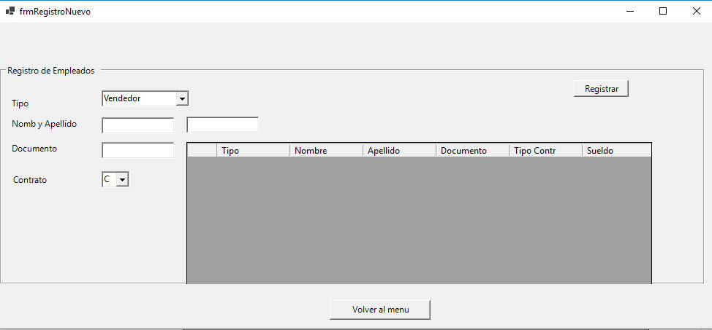

Imports Clases

Public Class frmRegistroNuevo

Private Sub BtnRegistrar_Click(sender As Object, e As EventArgs) Handles BtnRegistrar.Click

Dim empleado1 As Empleado = New Empleado()

empleado1.Nombres = TxtNombre.Text

empleado1.Apellidos = TxtApellido.Text

empleado1.Tipo = CboTipo.Text

empleado1.TipoContrato = CboContrato.Text

empleado1.Documento = TxtDocumento.Text

empleado1.calcularSueldo(750)

GrdDatos.Rows.Insert(0,

empleado1.Tipo,

empleado1.Nombres,

empleado1.Apellidos,

empleado1.Documento,

empleado1.TipoContrato,

empleado1.Sueldo)

End Sub

Private Sub BtnVolver_Click(sender As Object, e As EventArgs) Handles BtnVolver.Click

Menu.Show()

Me.Hide()

End Sub

End Class

**MENU**

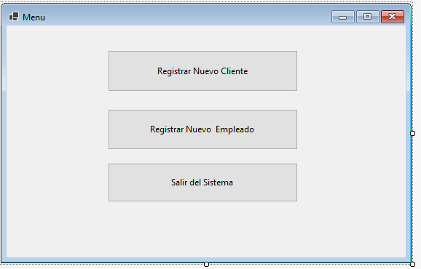

Public Class Menu

Private Sub BtnClientes_Click(sender As Object, e As EventArgs) Handles BtnClientes.Click

FrmRegistroCliente.Show()

frmRegistroNuevo.Hide()

End Sub

Private Sub BtnEmpleados_Click(sender As Object, e As EventArgs) Handles BtnEmpleados.Click

frmRegistroNuevo.Show()

FrmRegistroCliente.Hide()

End Sub

Private Sub BtnSalir_Click(sender As Object, e As EventArgs) Handles BtnSalir.Click

End

End Sub

End Class